Hello!

Welcome to the Cohort Daily Emailer Tool! This tool allows you to send a daily email assignment to members of your cohort. Since you choose the day the student starts to get the assignments, you can add a student to your cohort any day of the month!

The first time you open this spreadsheet every day it will send out the list of emails using Microsoft Outlook. All the later times it will open a MessageBox, telling you that the program has already been opened. This allows you to add students, or modify their information, once you double click okay.

You can add this program to the task scheduler of your laptop, so it automatically runs every morning before you start your shift. It sends out the emails, and then you can go in and add students or modify their information throughout your shift.

Here’s how to use this tool:

1. In this folder are a number of documents with names like Assignment1, Assignment2, etc. Copy your daily assignments into these files. Make additional assignments documents if you have more than the six included. These documents will be included as attachments on the emails.
2. Fill in the following information in the spreadsheet-number of daily emails in the cohort, subject line of the email, the name you sign the email with, the directory where you’re keeping the folder of emails, and the account you want the emailer to use to send it (your outlook must have access to send using this account)
3. Fill in the student number, name the email will be addressed to, address to send the email to, the task status and today’s date.

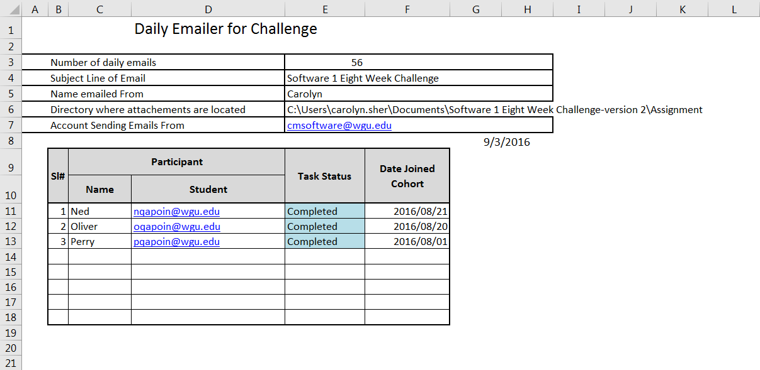

1. There are three ways for the emails to stop.
   1. The student asks you to remove them from the list, and you do.
   2. You choose a task status of Completed
   3. The number of days goes past the number of assignments, and the emailer stops sending assignments out.
2. The emails look like this (only nicer):

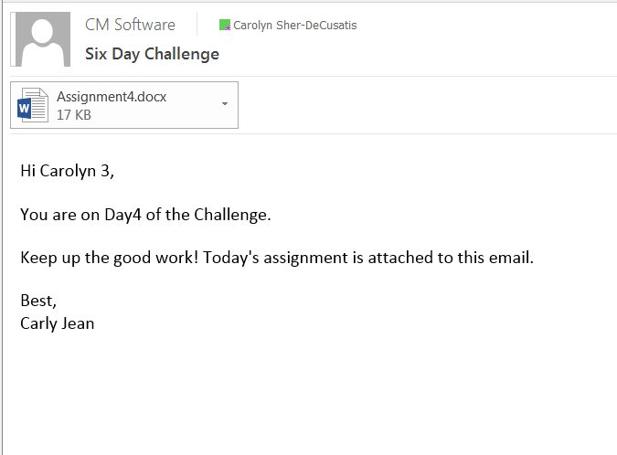

1. The way you set the program up to be opened automatically every day is:
   1. Go to the Control Panel (it should be visible after clicking the windows icon on the lower left hand corner of your computer)
   2. Search for Administrative Tools
   3. Under Administrative Tools, click on Task Scheduler

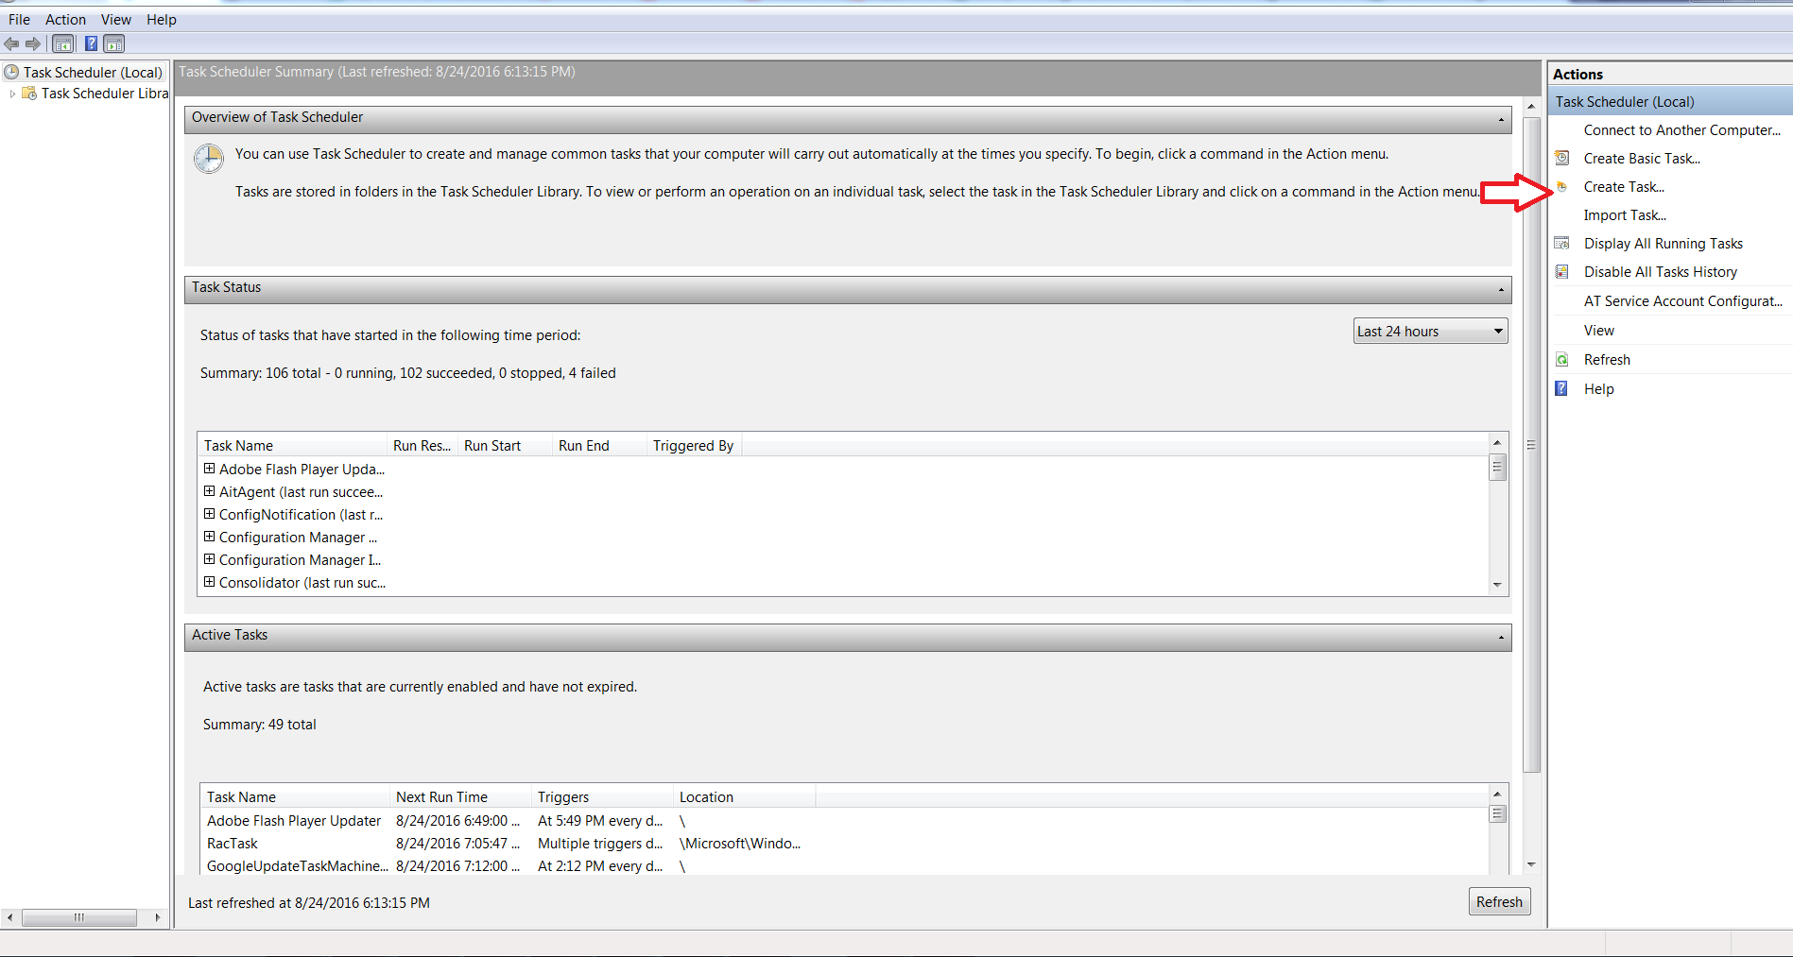

* 1. On the menu on the left hand side of the screen, click on Create Task\

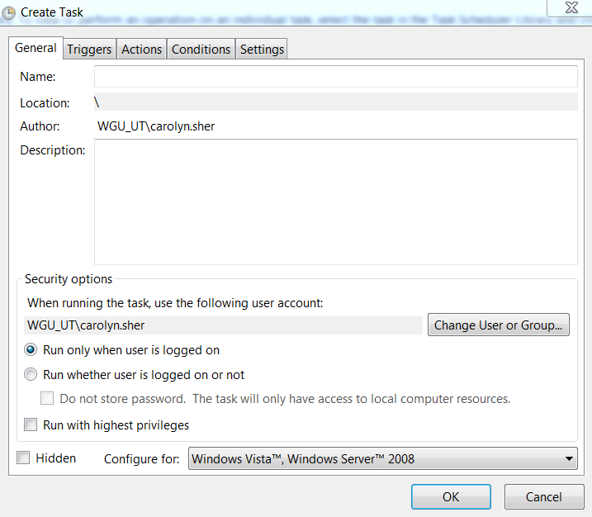

* 1. Under the General Tab give the task a name
  2. Under the Triggers Tab created a new Trigger, to begin the task on a schedule, and click on the Daily radio button and choose a time.
  3. Under the Actions Tab, create a New Action, to Start a program, and Browse your computer until you find the excel spreadsheet.

That’s all there is to it. I hope you find it helpful!